*Case Study 5.2****:* Sweet snacks & drinks**V.2.1



application data missing;

Life in Full Closed Loop is easy if your lifestyle largely consists of real meals, and not much other disturbances like from snacking (or from unusual exercise) in between. In section 4. we dealt with major meals.

Snacks come with the problem that they might even lead to steeper glucose rises, but overall a lesser insulin need. In section 5 therefore principal approaches were discussed how to deal with situations that lie outside of managing a “real” meal, or the “undisturbed” phases in between meals.

The following case study shows how “disturbances” can super easy be managed when coming from high carb snacks, from sweets, from consuming ice cream or having a sweet drink (like fruit juice, or spiced hot wine at the Christmas market = my example:)

Application example “Glühwein” for 1-button push “exception management” in Full Closed Loop

The following example shows how I can easy manage an “exceptional” situation that deviates from the average day and meal spectrum for which I made my settings in Full Closed Loop.

Glühwein is a sweet alcoholic drink served at Christmas markets. But really any sweet drink, sweet snack, ice cream etc. that does not amount to meal-size might be covered in very similar if not same way.

Tuning aggressiveness

Key is that I need even more aggressive FCL performance than for meals in my normal spectrum of diets.

Therefore, I can set

* a higher **temp. profile%** and/or
* a temp.elevated **bgAccel_ISF-weight** (see screenshot of my Automation).
* a **low temp. target** (76 for instance); it additionally helps maximize the first SMBs that will automatically be triggered at detection of acceleration.

When first defining and testing this Automation, also check:

* that the safety limits as discussed in section 2 will not block the intended elevated aggressiveness
* SMBs will not get outrageously big and iobTH sometimes exceeded by too mucht

Note that “the last SMB” is allowed to overshoot the valid iobTH by 30%

Limiting iob

For “just a snack”, insulin need will in total probably not amount to as much as for a meal.

If you would just have your sweet drink and your meal-oriented FCL would “attack”, iob likely would become too high, and a glucose rollercoaster would start, with you needing to consume more =>

If you just have a snack, or drink a glass of juice or Glühwein, you can lower the **iobTH_percent** accordingly.

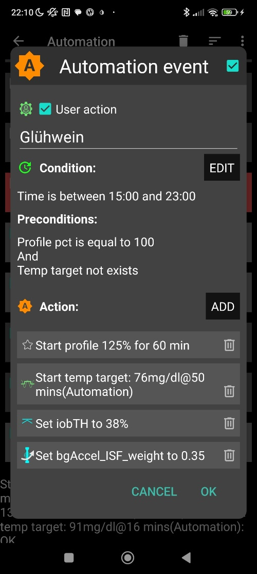

So, this is a little extra “project” when setting up your FCL. You need to research your snack habits (if any), and over time find out which settings in the snack-related Automation work well .

In everyday life you then just must press the related button in your cockpit (which is not time critical at all, except it should be clicked latest a couple of minutes after you took the drink or snack).

If you consume more, and also eat something with your sweet drink, this will more resemble a full meal… however, with unusual amounts of fast carbs. So you still profit of the more aggressive modulation regarding %profile and bgAccel_ISF, but in that case, you might keep the full default set iobTH_percent, or even elevate it (and label your Automation, and button, differently).

Installing the DIY cockpit button

Just have the “User action” box clicked at all times, and define in the Conditions when you want to see that button available for cockpit use (see screenshot above) => you will see that button offered.

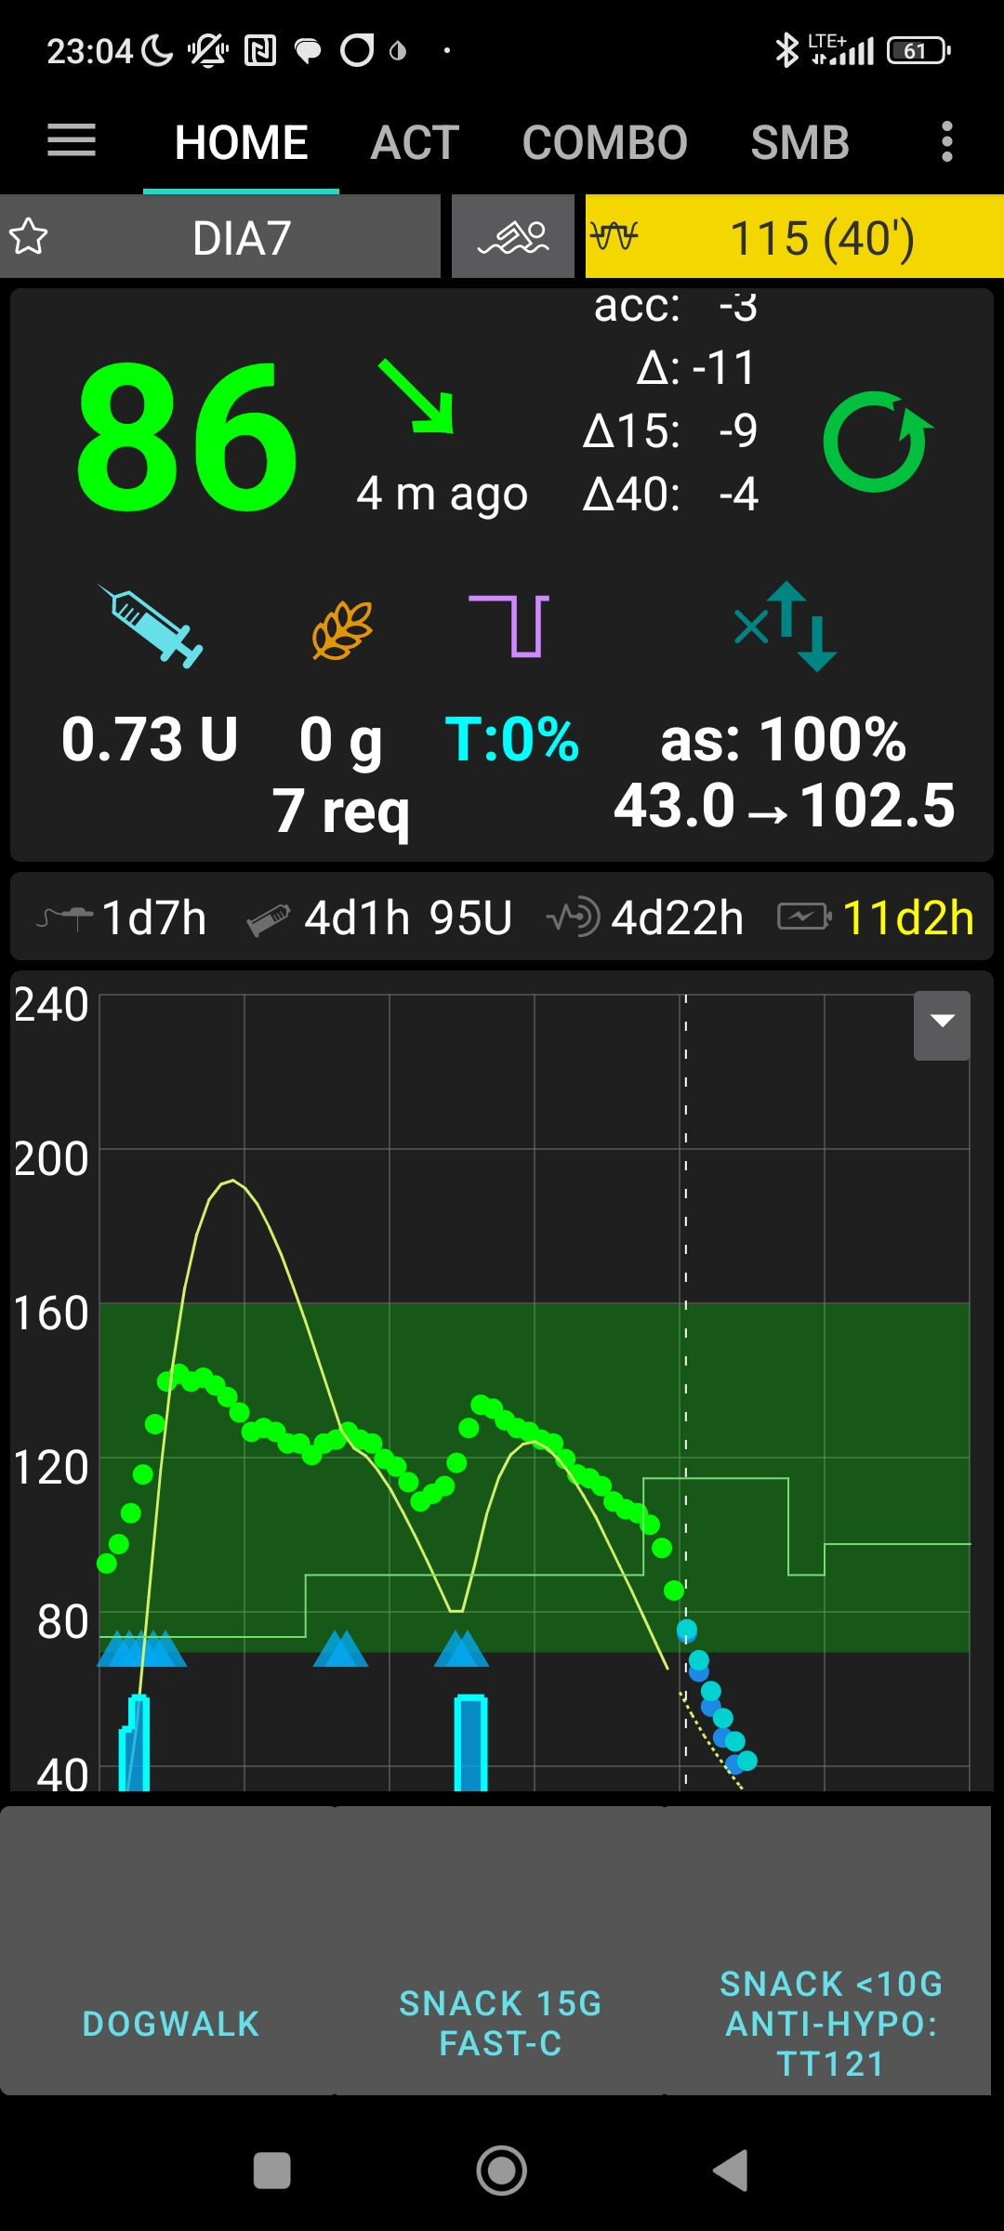

I named mine more generic

(also as headline in the related

Automation):

“Snack, 15 g fast Carbs”

Discussion

Outside of hypo prevention, I go usually with 2 meals and no snacks, especially no sweet drinks, through my days. So this Christmas market “Glühwein” really is a seasonal exception for me, and I probably will dis-activate this Automation soon (maybe to revive it when the ice cream season comes around ☺ …)

If I had regular snacking habits in certain parts of day, I might take an **alternative** route and **modify my FCL settings in those time slots** to run automatically upon acceleration detection.

Yet another **alternative** would be to temporarily leave the FCL mode and handle the sweet snack or drink “the traditional way” in **hybrid closed loop**. The suggested FCL cockpit user interface with an extra version of violet loop on the AAPS home screen facilitates that, including automatic removal and re-appearance of the insulin button at the bottom of the APS home screen.

As mentioned in section “Limiting iob” above, it is essential though to either avoid snacks, or select one of the discussed easy ways to deal with them in everyday life.

User experience

* add usage example(s) from after installing the User action Automation